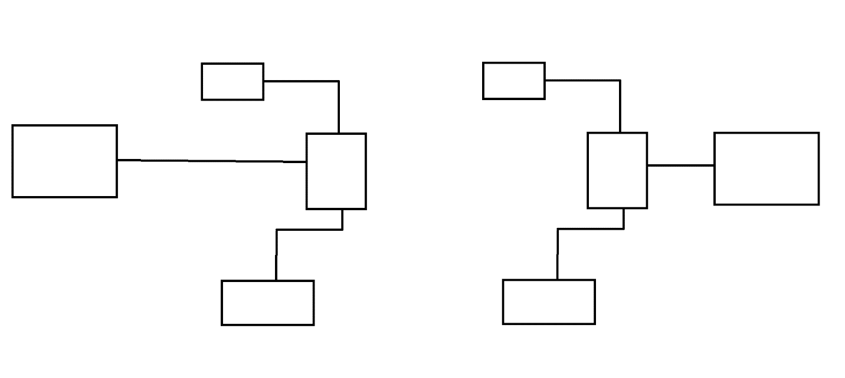

**0.96 12C OLED DISPLAY**

**LR1276/SX1276**

**RECEIVER SYSTEM**

**STM32 MICROCONTROLLER**

**STM32 MICROCONTROLLER**

**STM32 MICROCONTROLLER**

**STM32 MICROCONTROLLER**

**LR1276/SX1276**

**STM32 MICROCONTROLLER**

**STM32 MICROCONTROLLER**

**STM32 MICROCONTROLLER**

**STM32 MICROCONTROLLER**

**TRANSMITTER SYSTEM**

**DH11 SENSOR**